Day34, EmpID 1129116146

Task01

package Day10Sept;

import java.net.URI;
import java.util.List;
import java.util.Map;
import software.amazon.awssdk.regions.Region;
import software.amazon.awssdk.services.dynamodb.DynamoDbClient;
import software.amazon.awssdk.services.dynamodb.model.ListTablesResponse;
import software.amazon.awssdk.services.dynamodb.model.ScanRequest;
import software.amazon.awssdk.services.dynamodb.model.ScanResponse;
import software.amazon.awssdk.services.dynamodb.model.AttributeValue;

public class Task01 {
public static void main(String[] args) {
DynamoDbClient ddb = DynamoDbClient.builder()
.region(Region.US_EAST_1)
.endpointOverride(URI.create("http://localhost:8000"))
.build();

ListTablesResponse tables = ddb.listTables();
System.out.println("Tables in DynamoDB Local: " + tables.tableNames());

ScanRequest scanRequest = ScanRequest.builder()
.tableName("CustomerList")
.build();
ScanResponse response = ddb.scan(scanRequest);
List<Map<String, AttributeValue>> items = response.items();
for (Map<String, AttributeValue> item : items) {
System.out.println(item);
}
ddb.close();
}

}

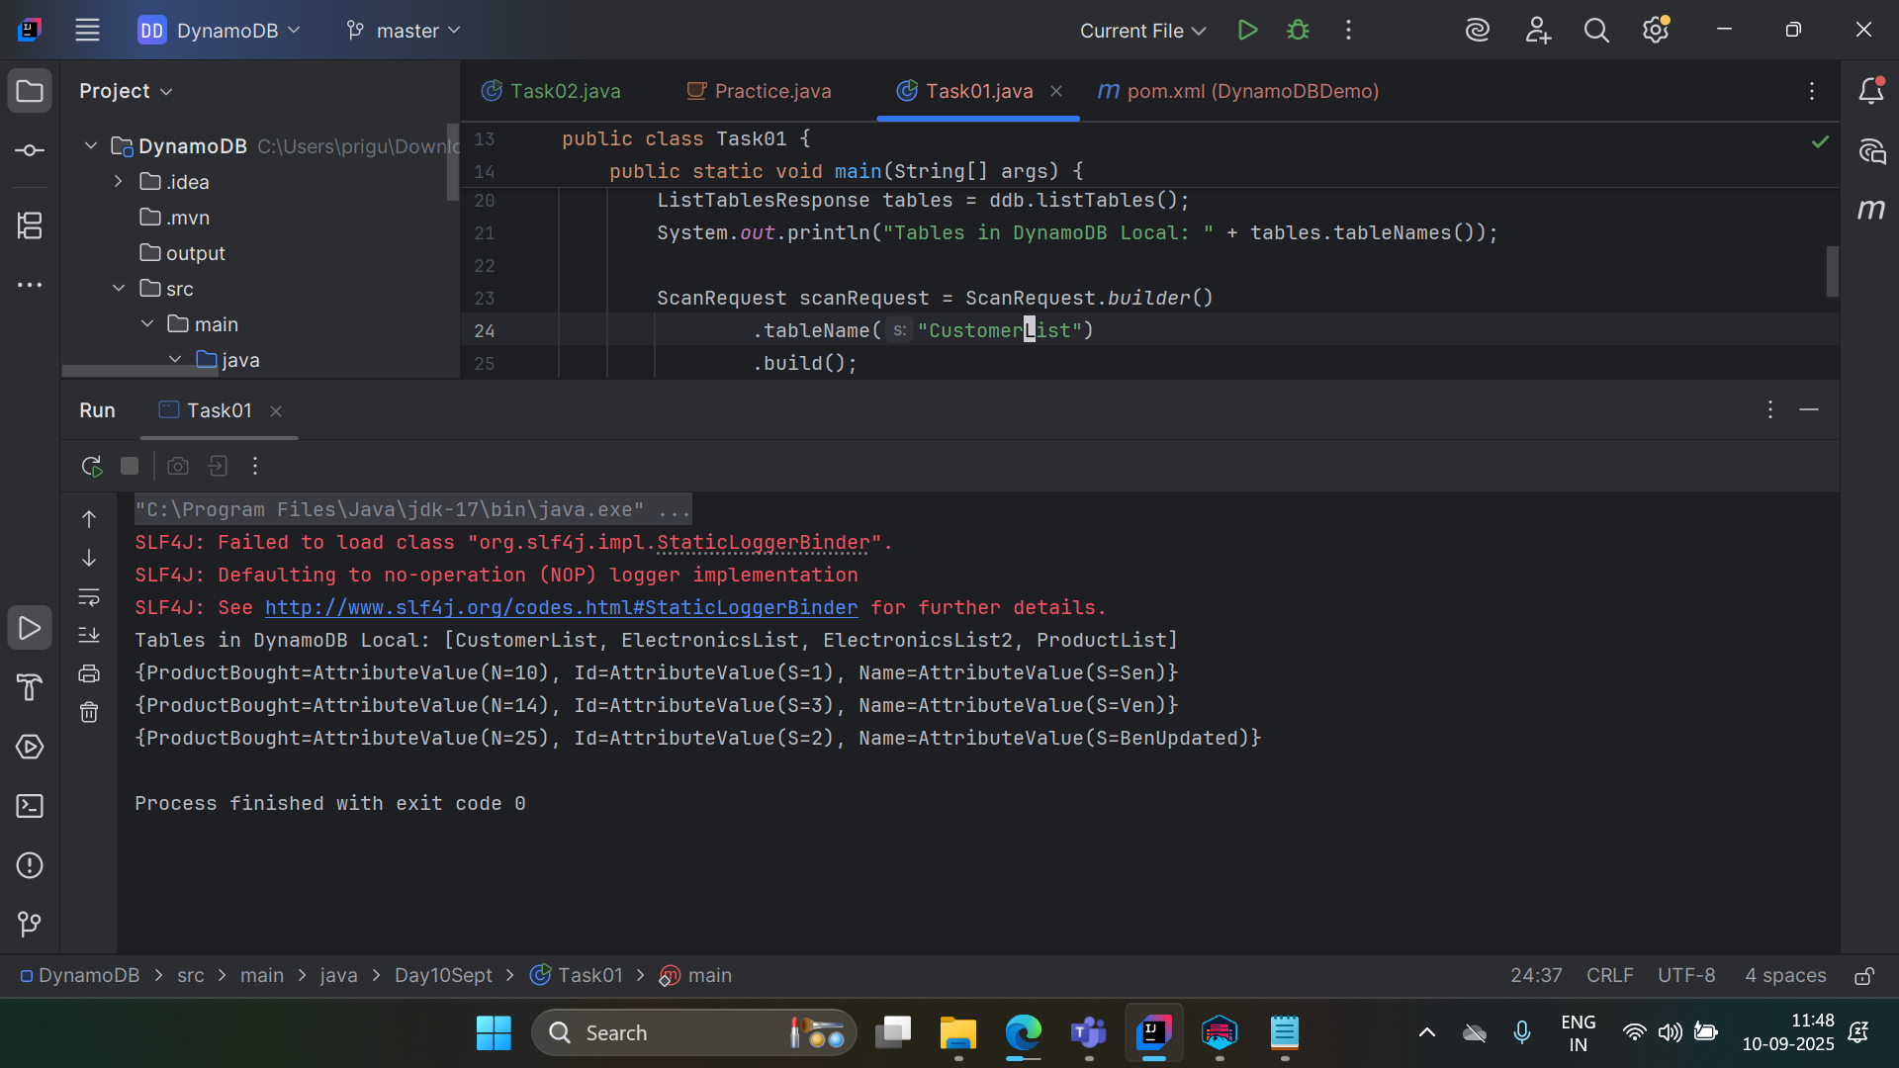

Task002

package Day10Sept;

import software.amazon.awssdk.regions.Region;
import software.amazon.awssdk.services.dynamodb.DynamoDbClient;
import software.amazon.awssdk.services.dynamodb.model.*;

import java.net.URI;
import java.util.HashMap;
import java.util.Map;

public class Task02 {
public static void main(String[] args) {

DynamoDbClient ddb = DynamoDbClient.builder()
.region(Region.US_EAST_1)
.endpointOverride(URI.create("http://localhost:8000"))
.build();

CreateTableRequest request = CreateTableRequest.builder()
.tableName("ElectronicsList")
.keySchema(KeySchemaElement.builder()
.attributeName("ID")
.keyType(KeyType.HASH)
.build())
.attributeDefinitions(AttributeDefinition.builder()
.attributeName("ID")
.attributeType(ScalarAttributeType.N)
.build())
.provisionedThroughput(ProvisionedThroughput.builder()
.readCapacityUnits(5L)
.writeCapacityUnits(5L)
.build())
.build();

ddb.createTable(request);
System.out.println("Products table created successfully!");

Map<String, AttributeValue> itemValues = new HashMap<>();
itemValues.put("ID", AttributeValue.builder().n("1").build());
itemValues.put("ProductName", AttributeValue.builder().s("Printer").build());
itemValues.put("Price", AttributeValue.builder().n("80000").build());

PutItemRequest putRequest = PutItemRequest.builder()
.tableName("ElectronicsList")
.item(itemValues)
.build();

ddb.putItem(putRequest);

// Product 2
Map<String, AttributeValue> itemValues2 = new HashMap<>();
itemValues2.put("ID", AttributeValue.builder().n("2").build());
itemValues2.put("ProductName", AttributeValue.builder().s("Laptop").build());
itemValues2.put("Price", AttributeValue.builder().n("120000").build());
itemValues2.put("Category", AttributeValue.builder().s("Electronics").build());

PutItemRequest putRequest2 = PutItemRequest.builder()
.tableName("ElectronicsList")
.item(itemValues2)
.build();

ddb.putItem(putRequest2);
System.out.println("Item inserted successfully!");
}
}

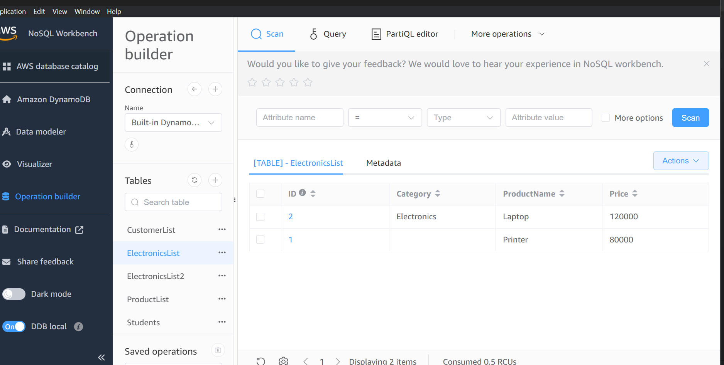

Task003

Key Features of DYnamoDb

- Fully Managed Service
  - No need to manage servers, OS, or patches.
  - AWS handles everything from scaling to replication.
- High Performance at Scale
  - Single-digit millisecond latency.
  - Can handle millions of requests per second.
- Flexible Schema
  - Items don’t require all attributes to be present.
  - Great for JSON-like hierarchical data and evolving apps.
- Automatic Scaling
  - On-demand or provisioned capacity mode.
  - Handles read/write scaling automatically without downtime.
- ACID Transactions
  - Supports atomic, consistent, isolated, durable operations across multiple items and tables.
- Global Tables
  - Multi-region replication for low-latency global access.
- High Availability & Durability
  - Replicated across multiple AZs (Availability Zones).
- Backup & Restore
  - On-demand backups.
  - Point-in-time recovery (PITR) for disaster recovery.

Task04

Advantages and Disdavantages

Advantages are same as key features

Disadvantages :

Cost Can Grow Quickly
- On-demand mode charges per read/write request.
- Provisioned mode may require careful RCU/WCU planning.
Limited Query Flexibility
- No SQL joins or complex queries.
- Must design data access patterns in advance.
Secondary Index Limitations
- Limited number of GSIs per table (default 20).
- LSI cannot exceed 10 per table and must share partition key.
Eventual Consistency by Default
- Reads may not immediately reflect writes.
- Strongly consistent reads are slower and more costly.
Size Limitations
- Maximum item size: 400 KB.
- Maximum table throughput and storage limits may apply.

Task 05

Real-Time Applications
- Description: Apps that need instant response times for read/write operations.
- Examples:
  - Chat apps (WhatsApp, Slack-like apps) storing messages.
  - Real-time gaming leaderboards.
  - IoT sensor data ingestion.
Why DynamoDB? Single-digit millisecond latency, auto-scaling writes and reads.

2️ E-Commerce & Catalog Management
- Description: Products, orders, and inventory management.
- Examples:
  - Product catalog with variable attributes (size, color, category).
  - Shopping cart storage per user session.
Why DynamoDB? Flexible schema, high throughput, easy integration with AWS Lambda.

3️ Session Management
- Description: Storing user sessions for websites or applications.
- Examples:
  - Web apps storing user login state.
  - Gaming apps tracking user sessions and progress.
Why DynamoDB? Fast reads/writes and can handle millions of concurrent users.

4️ Leaderboards & Real-Time Analytics
- Description: Store rankings or stats that update frequently.
- Examples:
  - Game scoreboards.
  - Sports stats dashboards.
Why DynamoDB? Ability to update items frequently with low latency.

5️ IoT Applications
- Description: Handling huge streams of sensor data.
- Examples:
  - Smart home devices.
  - Vehicle telemetry.
  - Industrial monitoring systems.
Why DynamoDB? Scales automatically to handle millions of writes per second.

6️ Mobile Applications
- Description: Backend storage for mobile apps requiring fast, offline-capable sync.
- Examples:
  - Mobile banking apps storing transactions.
  - Travel apps storing user preferences and bookings.
Why DynamoDB? AWS Amplify integrates seamlessly with DynamoDB for mobile apps.

Tassk 07

What are Projections?
In DynamoDB, a Projection defines which attributes are returned when you query or scan a table or access a secondary index.
Think of it like:
“I don’t need the entire row, I just want these specific columns.”

Projections are mainly used with secondary indexes:
- Global Secondary Index (GSI)
- Local Secondary Index (LSI)
When you create an index, you decide which attributes should be copied to the index.
This is called a projection.

3️ Types of Projections
There are three main types:
Projection Type | Description
KEYS_ONLY | Only the primary key attributes of the table (partition key + sort key) are projected into the index.
INCLUDE | You specify a subset of non-key attributes to include in the index. Useful if you don’t want all columns but some extra fields.
ALL | All attributes from the base table are projected into the index. This makes querying the index very flexible but consumes more storage.

Task 08
DynamoDB is a fully managed NoSQL database by AWS. Its architecture is designed to prevent data loss:
- Data is automatically replicated across multiple Availability Zones (AZs) in an AWS Region.
  - Each Region has at least 3 AZs.
  - Each item is stored redundantly in all AZs.
  - This is done synchronously, meaning a write is only acknowledged after all replicas in all AZs have stored the item.
- Durable storage
  - Data is stored on solid-state drives (SSDs).
  - AWS handles hardware failures automatically—if one server fails, other replicas serve the data.
DynamoDB prevents data loss through replication across multiple AZs, durable storage, and optional backups/PITR. Even AWS hardware failures won’t result in lost data.

Task 09

What does “in-place atomic update” mean?
- In-place update: You update an attribute of an item directly in the database without reading the entire item, modifying it, and writing it back.
- Atomic update: The update is done as a single, indivisible operation. It cannot be interrupted, and no other operation can see a partial change.
💡 In short: “Change just one attribute directly, safely, without affecting others.”

2️⃣ Does DynamoDB support it?
✅ Yes! DynamoDB supports in-place atomic updates using UpdateItem API with:
- ADD (increment numeric values or append to sets)
- SET (modify attributes)
- REMOVE (delete attributes)
These are atomic operations — DynamoDB guarantees that they happen all at once, even if multiple clients try to update the same item concurrently.

Task010

A DynamoDB Stream is a time-ordered sequence of changes (like insert, update, or delete) made to items in a DynamoDB table.
Think of it as:
“A history log of everything that changed in your table, in order, and available for 24 hours.”

2️ How it works
- Every time an item in the table is added, updated, or deleted, DynamoDB can write a stream record.
- The stream stores this record for 24 hours.
- You can process these records using AWS Lambda, Kinesis, or custom applications.

Task 011

DynamoDB Pricing is mainly based on:
- Read and Write Capacity (or usage for on-demand)
- Data storage
- Optional features (like Streams, Global Tables, Backups, and DAX)
AWS offers two main pricing models, also called tiers:

2️⃣ Pricing Tiers / Models

A. On-Demand Capacity Mode
- You pay per request.
- No need to specify read/write capacity units.
- Ideal for: unpredictable or low-traffic applications.
- Pricing (approx, can vary by region):
  - Write request unit (WRU): per 1 KB item
  - Read request unit (RRU): per 4 KB item
- Pros: Automatic scaling, pay only for what you use.
- Cons: More expensive if you have high, consistent traffic.

B. Provisioned Capacity Mode
- You specify how many read/write units your table needs.
- Read Capacity Unit (RCU):
  - 1 strongly consistent read of 4 KB per second
  - Or 2 eventually consistent reads of 4 KB per second
- Write Capacity Unit (WCU):
  - 1 write of 1 KB per second
- Ideal for: predictable workloads
- Pros: Can save money with predictable traffic, supports auto-scaling.
- Cons: Over-provisioning wastes money, under-provisioning throttles requests.

3️⃣ Additional Pricing Components
- Data Storage
  - Charged per GB per month.
- DynamoDB Streams
  - Charged per read request from the stream.
- Global Tables (multi-region replication)
  - Additional charges for replicated writes and storage.
- On-Demand Backup & Restore
  - Charged per GB of backup.
- Point-in-Time Recovery (PITR)
  - Charged per GB per month for continuous backups.
- DAX (DynamoDB Accelerator)
  - Optional in-memory caching service, billed per instance hour.

Task012
Yes! DynamoDB does have a maximum item size limit. Let’s go through it carefully.

1️⃣ Maximum Item Size
- An item in DynamoDB can be at most 400 KB in size.
- This includes:
  - The attribute names
  - The attribute values
  - Any metadata (like types)
💡 So if you have multiple attributes, their combined size cannot exceed 400 KB.

2️⃣ What counts toward the item size
- Strings: size in bytes (UTF-8 encoded)
- Numbers: size depends on storage format (not exactly bytes, but counts toward 400 KB)
- Binary attributes (B type)
- Lists and Maps: total size includes nested elements

Why this limit exists
- DynamoDB is optimized for fast, single-digit millisecond operations.
- Large items would slow down reads and writes, so AWS enforces 400 KB limit.

✅ In short:
- Max item size in DynamoDB = 400 KB.
- This includes all attribute names, values, and metadata.
- For larger data, use S3 + reference key or split items.

Task013
20

Task14

What is DynamoDB Accelerator (DAX)?
- DynamoDB Accelerator (DAX) is an in-memory caching service for DynamoDB.
- It reduces read latency from milliseconds to microseconds.
- Fully managed by AWS, so you don’t have to manage the cache nodes yourself.
💡 Think of it like Redis or Memcached specifically built for DynamoDB.

2️⃣ Why DAX is used
- Speed up read-heavy workloads
  - Normal DynamoDB reads: ~10 ms
  - DAX reads: ~0.1 ms (100× faster)
- Reduce read capacity usage
  - Reads served from cache don’t consume DynamoDB RCUs
- Seamless integration
  - Works with existing DynamoDB API calls (GetItem, Query, Scan)
  - Minimal code changes

Task015

What are Global Tables?
- Global Tables in DynamoDB allow you to replicate a table across multiple AWS regions automatically.
- They provide multi-region, fully managed, and active-active replication.
- This means you can read and write to the table in any region, and the changes are automatically propagated to all other regions.
💡 Think of it like:
“One table, multiple regions, always in sync.”

2️ Why use Global Tables
- High availability
  - If one region goes down, your application can still read/write from other regions.
- Low-latency access
  - Users get faster reads/writes because they can access the nearest region.
- Disaster recovery
  - Multi-region replication ensures data durability even if an entire region fails.
- Active-Active replication
  - Multiple regions can accept writes simultaneously.
  - DynamoDB handles conflict resolution automatically (last writer wins).

Task016

What is an Index in DynamoDB?
- An index is a data structure that improves the speed of queries on a table.
- In DynamoDB, it allows you to query the table using attributes other than the primary key.
- Think of it like an index in a book: you can quickly find the pages you need without reading the entire book.

Primary Key vs Secondary Index
Concept | Description
Primary Key | The main key used to uniquely identify items in a table (Partition Key + optional Sort Key).
Secondary Index | An alternate key structure that allows querying data in a different way without scanning the whole table.

Types of Secondary Indexes
DynamoDB supports two types of secondary indexes:

A. Local Secondary Index (LSI)
- Has the same Partition Key as the table but a different Sort Key.
- Can be created only at table creation time.
- Useful when you want to query items with the same Partition Key in multiple ways.

Task 17

Definition:
A hot key is a partition key value that is accessed (read/written) much more frequently than others.
Why it’s a problem:
DynamoDB distributes items across partitions based on the partition key. If one key is accessed disproportionately, all requests for that key go to the same physical partition → causing throttling and performance bottlenecks.
Example:
Imagine a table where:
- Partition key = UserID
- Millions of users exist, but all requests are for UserID = 123 (maybe it’s a celebrity’s profile).
Result → That one partition gets overloaded.

Hot Partitions
- Definition:
A hot partition happens when the partition (physical storage unit) itself receives much higher traffic compared to other partitions.
- Why it’s a problem:
DynamoDB automatically spreads partitions based on capacity. If your data distribution is skewed (some partitions getting too many requests, others sitting idle), you get throttling.
- Example:
Suppose you store logs with partition key = Date (like "2025-09-10").
  - Today’s date gets all writes.
  - Other dates (old ones) remain cold.
→ Today’s partition becomes hot.

Task 19

Table-Level Operations
👉 These operations deal with the entire table (structure, indexes, throughput, metadata, scans).
They don’t work on a single item, but on the whole table.

Examples:
- CreateTable → create a new DynamoDB table with keys, attributes, and throughput.
- DeleteTable → remove the entire table.
- DescribeTable → get metadata about the table (status, size, partitions, etc.).
- UpdateTable → modify table settings (provisioned capacity, global secondary indexes).
- ListTables → list all tables in your account/region.
- Scan → read through all items in the table (or a subset via filter).
- Query (kind of middle ground) → technically works on items, but across a partition key range, so often grouped under table-level reads.
Key Idea: Operates at table scale → affects many/all items.

2. Item-Level Operations
These operations deal with individual records (items) inside a table.
They are CRUD operations (Create, Read, Update, Delete) for specific items.

✅ Examples:
- PutItem → create/overwrite a single item.
- GetItem → fetch a single item by partition key (and sort key if applicable).
- UpdateItem → modify attributes of an existing item (supports atomic counters, conditional updates).
- DeleteItem → delete one specific item.
Key Idea: Operates at individual item granularity → affects one or a few records.

Enhanced MAPPER

- Main Class

package Day10Sept.Mapper;

import Day10Sept.Mapper.Students;

public class TestApp {
public static void main(String[] args) {
DBEnhancedClient db = new DBEnhancedClient();

// Save
Students s1 = new Students();
s1.setID("101");
s1.setName("Priya");
db.saveItem(s1);

// Retrieve
Students result = db.getItem("101");
if (result != null) {
System.out.println("Retrieved Student: " + result.getName());
} else {
System.out.println("No student found with ID 101");
}
}
}

Output 👍

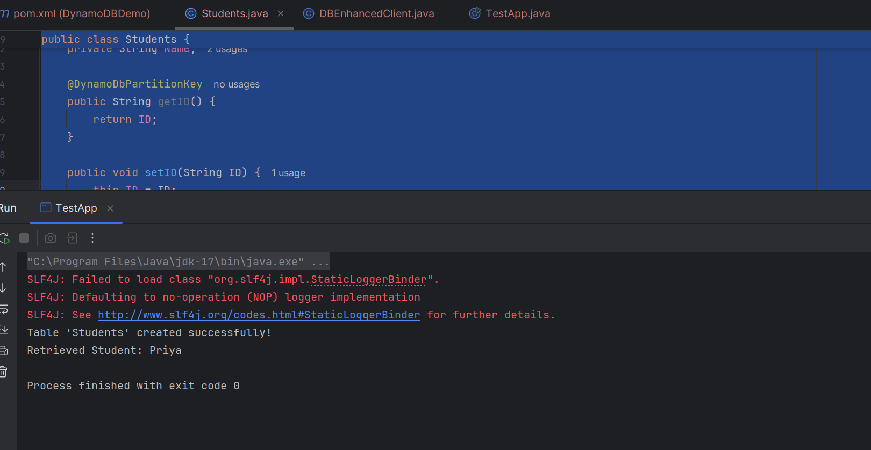

2.

Enhanced Class
package Day10Sept.Mapper;

import java.net.URI;
import software.amazon.awssdk.auth.credentials.AwsBasicCredentials;
import software.amazon.awssdk.auth.credentials.StaticCredentialsProvider;
import software.amazon.awssdk.regions.Region;
import software.amazon.awssdk.services.dynamodb.DynamoDbClient;
import software.amazon.awssdk.enhanced.dynamodb.*;
import software.amazon.awssdk.services.dynamodb.model.*;

public class DBEnhancedClient {

private final DynamoDbEnhancedClient enhancedClient;
private final DynamoDbTable<Students> studentTable;

public DBEnhancedClient() {
DynamoDbClient ddb = DynamoDbClient.builder()
.endpointOverride(URI.create("http://localhost:8000")) // DynamoDB Local
.region(Region.US_WEST_2) // region required
.credentialsProvider(StaticCredentialsProvider.create(
AwsBasicCredentials.create("dummy", "dummy"))) // dummy creds for local
.build();

this.enhancedClient = DynamoDbEnhancedClient.builder()
.dynamoDbClient(ddb)
.build();

this.studentTable = enhancedClient.table("Students", TableSchema.fromBean(Students.class));

createTableIfNotExists(); // Ensure table exists
}

// Create table if it doesn't exist
public void createTableIfNotExists() {
try {
studentTable.describeTable(); // Check if table exists
} catch (ResourceNotFoundException e) {
studentTable.createTable();
System.out.println("Table 'Students' created successfully!");
}
}

// Save student
public void saveItem(Students student) {
studentTable.putItem(student);
}

// Get student by ID
public Students getItem(String id) {
return studentTable.getItem(r -> r.key(k -> k.partitionValue(id)));
}
}

3. Student Class
package Day10Sept.Mapper;

import lombok.Data;
import software.amazon.awssdk.enhanced.dynamodb.mapper.annotations.DynamoDbBean;
import software.amazon.awssdk.enhanced.dynamodb.mapper.annotations.DynamoDbPartitionKey;

@Data
@DynamoDbBean
public class Students {

private String ID;
private String Name;

@DynamoDbPartitionKey
public String getID() {
return ID;
}

public void setID(String ID) {
this.ID = ID;
}

public String getName() {
return Name;
}

public void setName(String Name) {
this.Name = Name;
}
}

